Directorate General Resettlement
Ministry of Defence
brings together job seekers and job givers on a single platform at
DGR Ex-Servicemen Job Fair at Jammu
providing an opportunity
for second Innings in Employment to Ex-Servicemen
ON 29 MARCH 2023 AT ASC GROUND, NEAR MANDA ZOO, BC ROAD, JAMMU - 180007
TIMINGS : 08:00 AM ONWARDS

REGISTRATION FOR ALL EX-SERVICEMEN WILL BE CARRIED OUT AT THE VENUE

- Documents to carry: ESM to bring ESM I card and five copies of latest CV/Bio Data with photograph
- Dress for ESM : Open Collar/Mufti
- Entry on First Come First Serve Basis

Benefits for ESM Job Seekers
No cost access to Multiple Job Opportunities
Hassle Free Recruitment Process
Interact with Recruiters from Top PSUs/Corporates

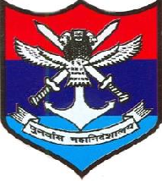 | For further queries & assistance, please contact  Joint Director (SE & CI) Directorate General Resettlement  West Block IV, RK Puram, New Delhi-110 066 Email : seopadgr@desw.gov.in  Tel: +91 1120862542 Website: http://www.dgrindia.gov.in

